

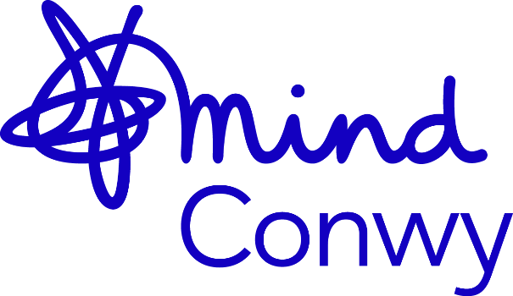

Conwy Mind Trustee
Information Pack

Conwy Mind
We are Conwy Mind, a leading mental health charity based in Abergele. We are an independent charity affiliated to National Mind covering Conwy County and Northwest Wales. Established in 1985, we have over 35 years’ experience of supporting better mental health and wellbeing across Conwy County. We are governed by our Board of Trustees.
We are committed to deliver services that meet the ever-changing needs of our community and involve service users with the design, development, delivery, and review of our services.
We want to be able to help as many people as possible and are committed to working with our community to challenge stigma and discrimination associated with mental health. Our inclusive services are accessible to everyone who needs them, ensuring no one has to face a mental health issue alone.
Mind Federation
Conwy Mind is affiliated to the Mind Federation a network made up of over 130 organisations across England and Wales delivering services, campaigning, and giving a voice to people with mental health issues, their families, carers and community. However, as with the other local Minds across the network, we are a stand-alone, independent charity responsible for our own fundraising and finances, governance and decision-making, development and staff and volunteer team. We do not receive funding from national Mind.
Our values and behaviours are at the heart of everything we do:
We put people first
- We respect and care for each other and the diverse communities where we live and work.
- We value every person as an individual and find strength in our differences.
- We listen carefully to make sure we really understand what people are saying.
We’re stronger together
- We embrace different points of view and work together to overcome our challenges.
- We’re a community, always looking for ways to team up, sharing information, resources and knowledge openly.
- We support each other, celebrate our shared successes and find joy in the everyday.
We speak up for what’s right
- We’re serious about equity and inclusion - if we see or hear something that’s not right, we don’t look the other way.
- We challenge each other with confidence and respect to find a way forward together.
- We speak out and fight injustice and discrimination in mental health, supporting others to do the same.
We never stop learning
- We’re curious, creative, and not afraid to try new things.
- We take responsibility for what we do, admit mistakes openly and share learning widely.
- We actively look for opportunities to learn and grow so we can do better for the people who need us.
We demand better for mental health
- We’re guided by lived experience, expertise, and evidence to make sure our work has the biggest impact.
- We look out for each other’s mental health when we work together.
- We’re passionate and determined people, always looking for ways to build a better future for mental health.
Governance
Conwy Mind is governed by a Board of Trustees who work with the Chief Executive and her Management Team in setting the strategic direction of the organisation.
Trustees are responsible for the Governance of the organisation, following Charity Commission Regulations. Conwy Mind is also a Company by Limited Guarantee, and the trustees are also Directors adhering to the regulations set by Companies House.
The day-to-day operations of Conwy Mind are delegated to the Chief Executive and her Management team.
Conwy Mind currently has a board of seven people with a varied range of skills and expertise; however, we are keen to grow our numbers. Details of our current trustees can be found on our website Our Trustees - Conwy Mind.
We are particularly looking for people with:
- Finance
- Fundraising
- Marketing
- HR Management
- Digital
- Business Management
This is not an exhaustive list and we would welcome applications from anyone with lived experience of mental health.

Responsibilities
Trustees share formal responsibility for the governance and strategic direction of Conwy Mind and must act in its best interest. They are expected to contribute actively to the function of the board of trustees providing strategic and governing oversight to the CEO and Senior Management Team. Some trustees may take on specific roles such as: Chair; Vice Chair; Treasurer or secretary.
As a trustee you will:
- Ensure your charity is carrying out its purpose for the public benefit.
- Comply with your charity’s governing document and the law.
- Act in your charity’s best interests
- Manage your charity’s resources responsibly.
- Act with reasonable care and skill.
- Ensure your charity is accountable.
In addition to the above statutory duties each trustee would be expected to use any specific skills knowledge or experience they have to help the board reach sound decisions. This could involve scrutinising board papers, leading discussions, focusing on key issues, providing advice and guidance on new initiatives, or other issues in the trustee has specific experience.
The trustee role is a voluntary one, however all reasonable out-of-pocket expenses incurred on charity business will be reimbursed in line with our volunteer expenses policy.
Our Commitment to you as a volunteer
You will have access to training, you will be assigned a “buddy” trustee to help you settle into the role. You will gain hands on experience of governance of a charity.
If you believe you have the skills and qualities we are looking for and can make a contribution to Conwy Mind we look forward to hearing from you.
Legal Requirements in the role of a Trustee
All trustees are legally responsible for the charity they govern. If you would like to find out more about these responsibilities, The Charity Commission for England and Wales have some helpful guidance on their website: (CC3a) Charity Trustee: What’s involved is a good source of information.
How to apply:
- If you are interested in becoming a trustee, contact Carol Cunningham: Chair of the Board – carol.cunningham@conwymind.org.uk
- The next step is to send an expression of interest (max 500 words) stating why you are interested in the role and what skills and attributes you aim to bring:
- If it is agreed to proceed to interview, you will be invited for a formal chat with the CEO, before proceeding to a formal interview with two of our trustees. The interview will provide an opportunity for them to get to know you, and for you to find out more about the role.
- If successful you will be asked to attend a Board Meeting and one sub-committee meeting as an observer. You will be invited to join the board once all requisite checks are carried out.

